6: Online Cake Ordering System
Aim: To design and develop an online cake ordering system that allows customers to browse cakes, filter products, add cakes to the cart, place orders, and track delivery status.
Algorithm:
- Start the application.
- Register and log in as a customer.
- Search and filter cakes by category, flavor, and price.
- View cake details, descriptions, and images.
- Select the desired cake and add it to the cart.
- Enter the shipping address and place the order.
- Complete the payment and confirm the order.
- Allow customers to view orders and track delivery status.
- Allow the administrator to manage cakes, images, orders, and shipping details.
- Stop.

Code :

<!DOCTYPE html>
<html lang="en">
<head>
<meta charset="UTF-8">
<meta name="viewport" content="width=device-width, initial-scale=1.0">
<title>Sweet Cake - Online Cake Ordering</title>

<style>
*{box-sizing:border-box}
body{margin:0;font-family:Arial,sans-serif;background:#fff7f8;color:#38232a}
header{background:#8b2346;color:white;padding:18px 5%;display:flex;
justify-content:space-between;align-items:center;flex-wrap:wrap;gap:12px}
header h1{margin:0;color:#ffe0e8}
nav{display:flex;gap:6px;flex-wrap:wrap}
button{background:#b83260;color:white;border:0;padding:10px 14px;
border-radius:6px;cursor:pointer;margin:3px}
button:hover{background:#8b2346}
main{max-width:1150px;margin:25px auto;padding:0 15px}
.panel{background:white;padding:22px;border-radius:12px;margin-bottom:20px;
box-shadow:0 3px 12px #0000000c}
h2{color:#8b2346;margin-top:0}
.grid{display:grid;grid-template-columns:repeat(auto-fit,minmax(210px,1fr));gap:18px}
.cake{border:1px solid #f3d4df;border-radius:10px;overflow:hidden;background:white}
.cake img{width:100%;height:175px;object-fit:cover}
.cake-info{padding:14px}
.cake h3{margin:5px 0;color:#8b2346}
label{display:block;font-weight:bold;margin-bottom:6px}
input,select,textarea{width:100%;padding:11px;margin-bottom:14px;
border:1px solid #e2bdca;border-radius:6px;font:inherit}
.row{display:grid;grid-template-columns:repeat(auto-fit,minmax(180px,1fr));gap:12px}
.hidden{display:none!important}
.notice{background:#ffeaf0;padding:13px;border-radius:7px;margin:10px 0}
.item{border-bottom:1px solid #f3d4df;padding:12px 0}
.danger{background:#c62828}
footer{text-align:center;padding:20px;color:#885b69}
.small{font-size:13px;color:#80636c}
@media(max-width:600px){header{padding:15px}.panel{padding:15px}}
</style>
</head>

<body>
<header>
<h1>🎂 Sweet Cake</h1>
<nav>
<button onclick="show('login')">Login</button>
<button onclick="show('register')">Register</button>
<button onclick="shop()">Cakes</button>
<button onclick="cartPage()">Cart 🛒 <span id="cartCount">0</span></button>
<button onclick="ordersPage()">My Orders</button>
<button onclick="adminLogin()">Admin</button>
<button onclick="logout()">Logout</button>
</nav>
</header>

<main>

<section id="login" class="panel">
<h2>Customer Login</h2>
<form id="loginForm">
<label>Email</label><input type="email" id="loginEmail" required>
<label>Password</label><input type="password" id="loginPassword" required>
<button>Login</button>
<button type="button" onclick="show('register')">Create Account</button>
</form>
<p id="loginMsg"></p>
</section>

<section id="register" class="panel hidden">
<h2>Create Account</h2>
<form id="registerForm">
<label>Full Name</label><input id="regName" required>
<label>Email</label><input id="regEmail" type="email" required>
<label>Phone Number</label><input id="regPhone" type="tel" required>
<label>Password (minimum 6 characters)</label>
<input id="regPassword" type="password" minlength="6" required>
<label>Confirm Password</label>
<input id="regConfirm" type="password" minlength="6" required>
<button>Register</button>
<button type="button" onclick="show('login')">Back to Login</button>
</form>
<p id="registerMsg"></p>
</section>

<section id="shop" class="panel hidden">
<h2>Our Delicious Cakes</h2>
<div class="row">
<div><label>Search Cake</label><input id="search" placeholder="Search by cake name"></div>
<div><label>Category</label>
<select id="category">
<option value="All">All Categories</option>
<option>Chocolate</option><option>Birthday</option>
<option>Fruit</option><option>Wedding</option>
</select></div>
<div><label>Maximum Price (₹)</label>
<input id="maxPrice" type="number" min="0" placeholder="e.g. 1000"></div>
</div>
<button onclick="renderCakes()">Apply Filters</button>
<div id="cakeList" class="grid"></div>
</section>

<section id="details" class="panel hidden">
<h2>Cake Details</h2>
<div id="cakeDetails"></div>
<button onclick="shop()">Back to Cakes</button>
</section>

<section id="cart" class="panel hidden">
<h2>Shopping Cart</h2>
<div id="cartItems"></div>
<h3 id="cartTotal">Total: ₹0</h3>
<button onclick="checkout()">Place Order</button>
<button onclick="shop()">Continue Shopping</button>
</section>

<section id="checkout" class="panel hidden">
<h2>Delivery Details</h2>
<form id="checkoutForm">
<label>Customer Name</label><input id="customerName" required>
<label>Phone Number</label><input id="customerPhone" type="tel" required>
<label>Delivery Address</label><textarea id="address" rows="3" required></textarea>
<label>Delivery Date</label><input id="deliveryDate" type="date" required>
<label>Payment Method</label>
<select id="paymentMethod">
<option>Cash on Delivery</option>
<option>UPI Demo</option>
<option>Card Demo</option>
</select>
<p class="small">UPI and card options are demo-only. No real payment is collected.</p>
<button>Confirm Order</button>
</form>
</section>

<section id="confirmation" class="panel hidden">
<h2>Order Placed Successfully!</h2>
<div id="confirmationInfo"></div>
<button onclick="printOrder()">Print Order</button>
<button onclick="ordersPage()">Track Order</button>
<button onclick="shop()">Order More Cakes</button>
</section>

<section id="orders" class="panel hidden">
<h2>My Orders and Delivery Tracking</h2>
<div id="orderList"></div>
</section>

<section id="admin" class="panel hidden">
<h2>Admin Dashboard</h2>
<div id="adminStats" class="notice"></div>
<h3>Add New Cake</h3>
<form id="cakeForm">
<label>Cake Name</label><input id="newName" required>
<label>Category</label>
<select id="newCategory"><option>Chocolate</option><option>Birthday</option>
<option>Fruit</option><option>Wedding</option></select>
<label>Price (₹)</label><input id="newPrice" type="number" min="1" required>
<label>Image URL</label><input id="newImage" type="url" placeholder="https://example.com/cake.jpg" required>
<label>Description</label><textarea id="newDescription" required></textarea>
<button>Add Cake</button>
</form>
<h3>Manage Products</h3><div id="manageCakes"></div>
<h3>Manage Customer Orders</h3><div id="manageOrders"></div>
</section>

</main>
<footer>Sweet Cake | Internet Programming Lab Experiment</footer>

<script>
const $=id=>document.getElementById(id);

function read(key){
try{return JSON.parse(localStorage.getItem(key))||[]}
catch(e){return []}
}
function save(key,value){localStorage.setItem(key,JSON.stringify(value))}
function currentUser(){
try{return JSON.parse(sessionStorage.getItem("sweetUser"))}
catch(e){return null}
}
function show(id){
document.querySelectorAll("main>section").forEach(s=>s.classList.add("hidden"));
$(id).classList.remove("hidden");
window.scrollTo({top:0,behavior:"smooth"});
}
function requireLogin(){
if(!currentUser()){
alert("Please register or log in first.");
show("login");
return false;
}
return true;
}

const initialCakes=[
{id:1,name:"Chocolate Cake",category:"Chocolate",price:650,
image:"https://images.unsplash.com/photo-1578985545062-69928b1d9587?w=600",
description:"Rich chocolate cake with creamy chocolate frosting."},
{id:2,name:"Birthday Cake",category:"Birthday",price:900,
image:"https://images.unsplash.com/photo-1558636508-e0db3814bd1d?w=600",
description:"Beautiful celebration cake for special birthdays."},
{id:3,name:"Strawberry Cake",category:"Fruit",price:750,
image:"https://images.unsplash.com/photo-1565958011703-44f9829ba187?w=600",
description:"Soft cake with strawberry flavour and cream."},
{id:4,name:"Wedding Cake",category:"Wedding",price:2500,
image:"https://images.unsplash.com/photo-1535254973040-607b474cb50f?w=600",
description:"Elegant layered cake for wedding celebrations."},
{id:5,name:"Black Forest Cake",category:"Chocolate",price:800,
image:"https://images.unsplash.com/photo-1606313564200-e75d5e30476c?w=600",
description:"Chocolate sponge, cream and cherry-inspired layers."},
{id:6,name:"Fruit Celebration Cake",category:"Fruit",price:700,
image:"https://images.unsplash.com/photo-1464349095431-e9a21285b5f3?w=600",
description:"Delicious fruit cake for family celebrations."}
];

if(!localStorage.getItem("sweetCakes"))save("sweetCakes",initialCakes);

function updateCartCount(){
const cart=read("sweetCart");
$("cartCount").textContent=cart.reduce((s,x)=>s+x.qty,0);
}
function shop(){
if(!requireLogin())return;
renderCakes();show("shop");
}

$("registerForm").addEventListener("submit",e=>{
e.preventDefault();
const users=read("sweetUsers");
const email=$("regEmail").value.trim().toLowerCase();
const password=$("regPassword").value;
if(password!==$("regConfirm").value){
$("registerMsg").textContent="Passwords do not match.";return;
}
if(password.length<6){
$("registerMsg").textContent="Password must have at least 6 characters.";return;
}
if(users.some(u=>u.email===email)){
$("registerMsg").textContent="Email already registered.";return;
}
users.push({name:$("regName").value.trim(),email,
phone:$("regPhone").value.trim(),password});
save("sweetUsers",users);
$("registerForm").reset();
alert("Registration successful! Please log in.");
show("login");
});

$("loginForm").addEventListener("submit",e=>{
e.preventDefault();
const email=$("loginEmail").value.trim().toLowerCase();
const password=$("loginPassword").value;
const u=read("sweetUsers").find(x=>x.email===email&&x.password===password);
if(!u){$("loginMsg").textContent="Invalid email or password.";return}
sessionStorage.setItem("sweetUser",JSON.stringify({
name:u.name,email:u.email,phone:u.phone
}));
$("loginMsg").textContent="";
alert("Welcome "+u.name+"!");
shop();
});

function logout(){
sessionStorage.removeItem("sweetUser");
alert("Logged out successfully.");
show("login");
}

function renderCakes(){
const cakes=read("sweetCakes");
const term=$("search").value.trim().toLowerCase();
const cat=$("category").value;
const max=$("maxPrice").value;
$("cakeList").innerHTML="";
const filtered=cakes.filter(c=>
c.name.toLowerCase().includes(term)&&
(cat==="All"||c.category===cat)&&
(max===""||c.price<=Number(max))
);
if(!filtered.length){
$("cakeList").textContent="No cakes match your filters.";return;
}
filtered.forEach(c=>{
const card=document.createElement("article");card.className="cake";
const img=document.createElement("img");
img.src=c.image;img.alt=c.name;
img.onerror=()=>{img.style.display="none"};
const info=document.createElement("div");info.className="cake-info";
const title=document.createElement("h3");title.textContent=c.name;
const price=document.createElement("p");price.textContent="₹"+c.price;
const catText=document.createElement("p");catText.textContent=c.category;
const detail=document.createElement("button");detail.textContent="View Details";
detail.onclick=()=>viewDetails(c.id);
const add=document.createElement("button");add.textContent="Add to Cart";
add.onclick=()=>addToCart(c.id);
info.append(title,catText,price,detail,add);
card.append(img,info);$("cakeList").appendChild(card);
});
}
$("search").addEventListener("input",renderCakes);
$("category").addEventListener("change",renderCakes);

function viewDetails(id){
const c=read("sweetCakes").find(x=>x.id===id);
if(!c)return;
$("cakeDetails").innerHTML="";
const img=document.createElement("img");
img.src=c.image;img.alt=c.name;
img.style="width:100%;max-width:400px;border-radius:10px";
img.onerror=()=>{img.style.display="none"};
const title=document.createElement("h3");title.textContent=c.name;
const price=document.createElement("h3");price.textContent="₹"+c.price;
const desc=document.createElement("p");desc.textContent=c.description;
const add=document.createElement("button");add.textContent="Add to Cart";
add.onclick=()=>addToCart(c.id);
$("cakeDetails").append(img,title,price,desc,add);
show("details");
}

function addToCart(id){
if(!requireLogin())return;
const cart=read("sweetCart"),item=cart.find(x=>x.id===id);
if(item)item.qty++;
else cart.push({id,qty:1});
save("sweetCart",cart);updateCartCount();
alert("Cake added to cart.");
}
function cartPage(){
if(!requireLogin())return;
renderCart();show("cart");
}
function renderCart(){
const cart=read("sweetCart"),cakes=read("sweetCakes");
$("cartItems").innerHTML="";
let total=0;
cart.forEach(item=>{
const c=cakes.find(x=>x.id===item.id);
if(!c)return;
total+=c.price*item.qty;
const div=document.createElement("div");div.className="item";
const text=document.createElement("p");
text.textContent=c.name+" × "+item.qty+" = ₹"+c.price*item.qty;
const minus=document.createElement("button");minus.textContent="-";
minus.onclick=()=>changeQty(c.id,-1);
const plus=document.createElement("button");plus.textContent="+";
plus.onclick=()=>changeQty(c.id,1);
const remove=document.createElement("button");remove.textContent="Remove";
remove.className="danger";remove.onclick=()=>removeCart(c.id);
div.append(text,minus,plus,remove);$("cartItems").appendChild(div);
});
if(!cart.length)$("cartItems").textContent="Your cart is empty.";
$("cartTotal").textContent="Total: ₹"+total;
updateCartCount();
}
function changeQty(id,delta){
const cart=read("sweetCart"),item=cart.find(x=>x.id===id);
if(item)item.qty+=delta;
save("sweetCart",cart.filter(x=>x.qty>0));renderCart();
}
function removeCart(id){
save("sweetCart",read("sweetCart").filter(x=>x.id!==id));renderCart();
}
function checkout(){
if(!requireLogin())return;
if(!read("sweetCart").length){alert("Your cart is empty.");return}
const u=currentUser();
$("customerName").value=u.name;
$("customerPhone").value=u.phone||"";
$("deliveryDate").min=new Date().toISOString().slice(0,10);
show("checkout");
}

$("checkoutForm").addEventListener("submit",e=>{
e.preventDefault();
const u=currentUser();
if(!u){alert("Please log in again.");show("login");return}
const cart=read("sweetCart"),cakes=read("sweetCakes");
if(!cart.length){alert("Cart is empty.");show("shop");return}
const items=cart.map(i=>{
const c=cakes.find(x=>x.id===i.id);
return c?{id:c.id,name:c.name,price:c.price,qty:i.qty}:null;
}).filter(Boolean);
if(!items.length){alert("Your cart is empty.");return}
const order={
id:"CAKE"+Date.now(),email:u.email,
customer:$("customerName").value.trim(),
phone:$("customerPhone").value.trim(),
address:$("address").value.trim(),
deliveryDate:$("deliveryDate").value,
payment:$("paymentMethod").value,
items,total:items.reduce((s,x)=>s+x.price*x.qty,0),
status:"Order Placed",created:new Date().toLocaleString()
};
const orders=read("sweetOrders");orders.push(order);save("sweetOrders",orders);
save("sweetCart",[]);updateCartCount();
showConfirmation(order);
});

function showConfirmation(o){
$("confirmationInfo").innerHTML="";
[["Order ID",o.id],["Customer",o.customer],["Items",o.items.map(i=>i.name+" × "+i.qty).join(", ")],
["Total","₹"+o.total],["Delivery Date",o.deliveryDate],["Address",o.address],
["Payment",o.payment],["Status",o.status]].forEach(([k,v])=>{
const p=document.createElement("p"),b=document.createElement("strong");
b.textContent=k+": ";p.append(b,document.createTextNode(v));
$("confirmationInfo").appendChild(p);
});
show("confirmation");
}
function ordersPage(){
if(!requireLogin())return;
const u=currentUser();
$("orderList").innerHTML="";
const orders=read("sweetOrders").filter(o=>o.email===u.email).reverse();
if(!orders.length){$("orderList").textContent="No orders found.";show("orders");return}
orders.forEach(o=>{
const div=document.createElement("div");div.className="item";
const p=document.createElement("p");
p.textContent=o.id+" | ₹"+o.total+" | Delivery: "+o.deliveryDate+
" | Status: "+o.status+" | Items: "+o.items.map(i=>i.name+" × "+i.qty).join(", ");
div.appendChild(p);$("orderList").appendChild(div);
});
show("orders");
}
function printOrder(){
const info=$("confirmationInfo").innerText;
const w=window.open("","_blank");
if(!w){alert("Allow pop-ups to print.");return}
const p=document.createElement("p");p.textContent=info;
w.document.body.appendChild(p);w.document.title="Sweet Cake Order";
w.document.close();w.print();
}

// Demo admin password: admin123
function adminLogin(){
if(prompt("Enter demo admin password:")!=="admin123"){
alert("Incorrect password.");return;
}
renderAdmin();show("admin");
}
function renderAdmin(){
const orders=read("sweetOrders"),cakes=read("sweetCakes");
$("adminStats").textContent="Products: "+cakes.length+
" | Orders: "+orders.length+" | Order value: ₹"+
orders.reduce((s,o)=>s+o.total,0);
$("manageCakes").innerHTML="";
cakes.forEach(c=>{
const div=document.createElement("div");div.className="item";
const p=document.createElement("p");p.textContent=c.name+" - ₹"+c.price;
const del=document.createElement("button");del.textContent="Delete Cake";
del.className="danger";del.onclick=()=>{
if(confirm("Delete "+c.name+"?")){
save("sweetCakes",read("sweetCakes").filter(x=>x.id!==c.id));
renderAdmin();
}
};
div.append(p,del);$("manageCakes").appendChild(div);
});
$("manageOrders").innerHTML="";
orders.forEach(o=>{
const div=document.createElement("div");div.className="item";
const p=document.createElement("p");
p.textContent=o.id+" | "+o.customer+" | ₹"+o.total+" | "+o.status;
const select=document.createElement("select");
["Order Placed","Preparing","Out for Delivery","Delivered","Cancelled"].forEach(s=>{
const opt=document.createElement("option");opt.value=s;opt.textContent=s;
if(s===o.status)opt.selected=true;select.appendChild(opt);
});
select.onchange=()=>{
const all=read("sweetOrders"),i=all.findIndex(x=>x.id===o.id);
if(i>=0)all[i].status=select.value;
save("sweetOrders",all);renderAdmin();
};
div.append(p,select);$("manageOrders").appendChild(div);
});
}
$("cakeForm").addEventListener("submit",e=>{
e.preventDefault();
const cakes=read("sweetCakes");
cakes.push({id:Date.now(),name:$("newName").value.trim(),
category:$("newCategory").value,price:Number($("newPrice").value),
image:$("newImage").value,description:$("newDescription").value.trim()});
save("sweetCakes",cakes);$("cakeForm").reset();
renderAdmin();alert("Cake added successfully.");
});
updateCartCount();
show("login");
</script>
</body>
</html>

Output :
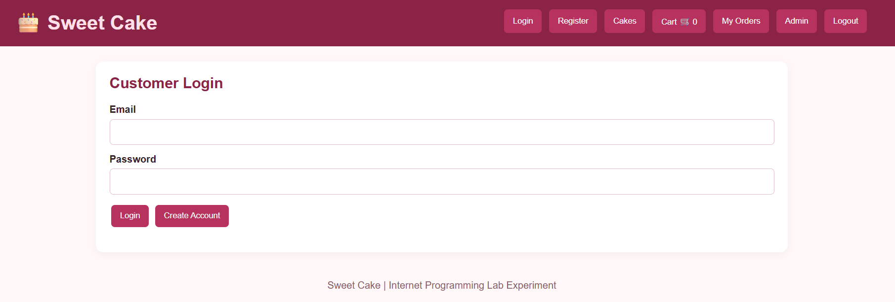
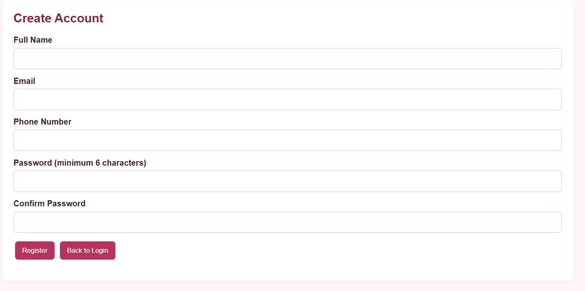
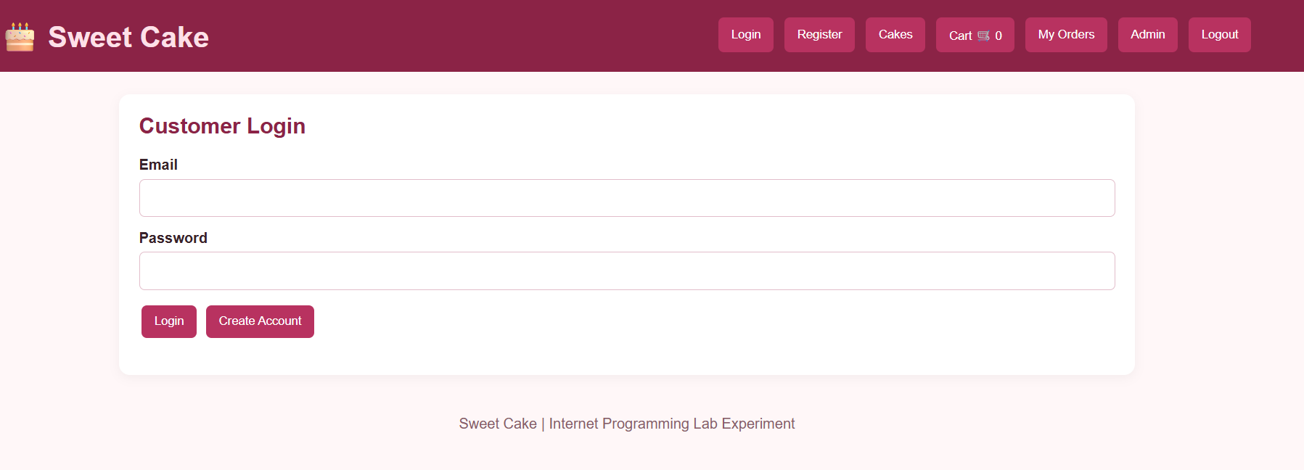
Result : Thus, the online cake ordering system was developed successfully to enable customers to purchase cakes online and track their orders conveniently.

